Yes, the **Dell Latitude 3550** is certified by Canonical for use with Ubuntu, specifically Ubuntu 22.04 LTS. According to Canonical’s certification database, the Latitude 3550 (Quake-L MLK 15 platform) has been tested and verified to work with Ubuntu 22.04 LTS, using a custom Ubuntu image that optimizes hardware features and may include additional software.

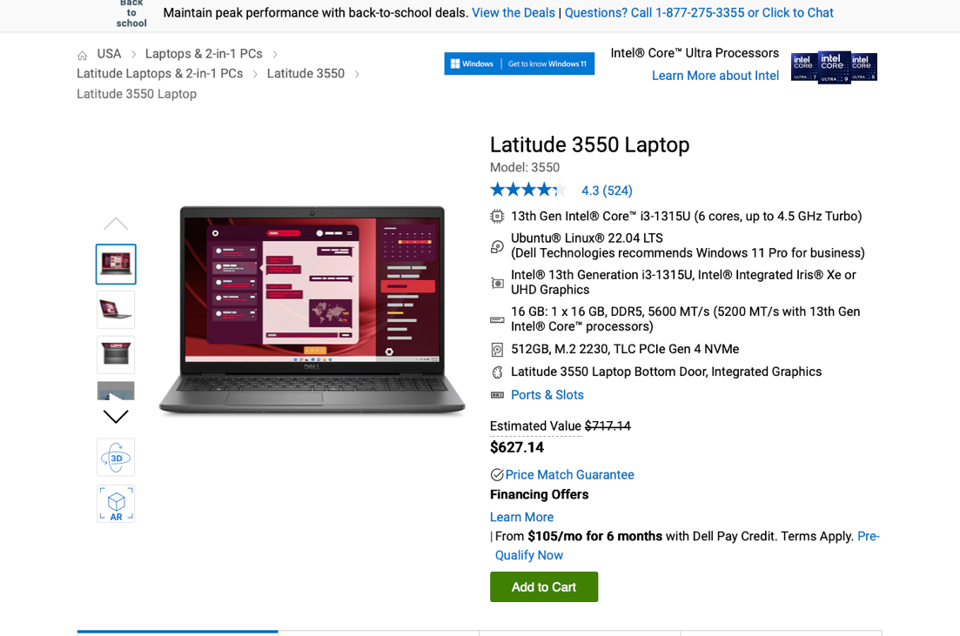

Standard Ubuntu images may not perform as well or may require all available updates to function properly.
(https://website-content-cache-1.canonical.com/certified/202312-33229)
(https://ubuntu.com/certified/202312-33229)[](https://ubuntu.com/certified/platforms/14622/22.04%2520LTS)

Relevance to Your Use Case
For your goal of obtaining a US Government-acceptable laptop pre-installed with Ubuntu for DISA NIST STIG compliance using Ubuntu Pro and the Ubuntu Security Guide (USG) toolset, the Dell Latitude 3550 is a suitable choice:
- Ubuntu 22.04 LTS Certification: The Latitude 3550’s certification ensures full hardware compatibility (e.g., processor, graphics, Wi-Fi, docking stations), making it ready for STIG compliance with Ubuntu Pro and USG.

You can automate hardening and auditing for the Ubuntu 22.04 LTS STIG (published April 2024) by performing the following steps:

1. Using the browser (typically Firefox) installed on the Ubuntu system navigate to https://ubuntu.com/pro and select “Get Ubuntu Pro Now”. You may be prompted to set-up an account.
2. When prompted who will be using this subscription select “Myself” (for less than 5 users) or “My Organization” for paid desktop subscriptions at $25/year each.
3. Copy the token to your clipboard.
4. Open terminal.
Enter the command ‘pwd’ to see what directory you are in. It should be /home/username where username = the logon name you used like bsmith etc.
Next, enter the following commands: (do not enter the # or what follows it as these are comments):

sudo apt update && sudo apt upgrade -y # updates the list of packages.
sudo pro attach <token> # replace <token> with the value copied to your clipboard to attach Ubuntu Pro subscription to the system
sudo pro enable usg # Enable Ubuntu Security Guide tool
sudo usg audit --profile disa_stig # Audit system
sudo usg fix --profile disa_stig # Remediate non-compliant settings

Note: the fix process can take a while – you may see a command echoed to your screen like “aide init” which may take several minutes to a couple of hours to complete … be patient!

7. In terminal enter the command ‘reboot’ and allow the system to restart.

8. Once the system has completed its reboot, log in and open the terminal again. Enter
sudo usg audit --profile disa_stig #reaudit system post remediation

9. Reports of the audit are stored in /var/lib/usg however that directory is locked. and you won’t be able to access it directly.
Try this command:
sudo cp /var/lib/usg/*.html /home/username/Documents
sudo chown username /home/username/Documents/*
sudo chmod 766 /home/username/Documents/*.html

If this works you should be able to use the GUI to see the files in the document (or file) manager. If so right-click on the file of interest (note the datestamp in the file name with the .xxxx being the time of creation) and open in your browser.

Done!

- **FIPS Compliance**: Ubuntu 22.04 LTS supports FIPS 140-3 modules (in preview, pending NIST certification), meeting STIG cryptographic requirements. Ubuntu 20.04 LTS, also supported on some Dell models, offers FIPS 140-2 (certified until 2026) if immediate certification is needed.
- **US Government Acceptability**: Dell is a trusted US-based vendor, widely used in government environments, with no supply chain concerns like those associated with Lenovo. The Latitude 3550’s enterprise-grade features (e.g., durability, long battery life, optional 4G LTE) align with DoD procurement standards.
(https://www.dell.com/en-us/shop/dell-laptops/scr/laptops/appref=latitude-product-line)

### Additional Details
- **Hardware Specifications**: The Latitude 3550 supports up to Intel Core i3-1315U processors, Intel Iris Xe or UHD Graphics, up to 32 GB RAM, and a 15-inch display. It’s designed for professionals, offering features like an optional HDR webcam and DDR5 memory for faster performance.
(https://www.dell.com/en-us/shop/dell-laptops/scr/laptops/appref=ubuntu-linux-os)
(https://www.dell.com/en-us/shop/dell-laptops/latitude-3550-laptop/spd/latitude-15-3550-laptop/gctol3550usvp?redirectTo=SOC)
- **Canonical Certification**: The certification process involves over 500 hardware compatibility tests, ensuring reliability and performance out of the box. Canonical’s continuous testing throughout the Ubuntu release lifecycle guarantees stable updates.
(https://ubuntu.com/certified?limit=480&category=Laptop&release=20.04%2BLTS&release=18.04%2BLTS)[](https://ubuntu.com/certified)
- **Availability**: The Latitude 3550 with Ubuntu 22.04 LTS is available on dell.com, starting at $469.00 for the base configuration. Check government procurement channels (e.g., GSA Advantage) for DoD-specific pricing or configurations.
(https://www.dell.com/en-us/shop/dell-laptops/latitude-3550-laptop/spd/latitude-15-3550-laptop/gctol3550usvp?redirectTo=SOC)
- **STIG Compliance Efficiency**: The Latitude 3550’s Ubuntu 22.04 LTS certification ensures compatibility with Ubuntu Pro’s USG toolset, which automates over 300 STIG rules, minimizing manual configuration. For site-specific settings (e.g., GRUB passwords, logging servers), manual adjustments may be needed, but USG streamlines the process significantly.

### Recommendation
The **Dell Latitude 3550** with Ubuntu 22.04 LTS is an excellent choice for your requirements. It’s Canonical-certified, supports Ubuntu Pro and USG for rapid STIG compliance, and is available with or without the DCA-Enabler. For simplicity, select the standard Ubuntu 22.04 LTS configuration unless your organization requires WMS integration. If you need higher performance, consider the **Dell XPS 13 Developer Edition** or **Precision workstations** (also certified for Ubuntu 22.04 LTS) as alternatives, though the Latitude 3550’s affordability and enterprise features make it well-suited for government use. Verify availability and configurations on dell.com or through DoD procurement channels, and consult ubuntu.com/certified for the latest certification details.[](https://canonical.com/blog/dell-xps-13-plus-developer-edition-now-certified-with-ubuntu-22-04-lts)[](https://www.dell.com/en-us/shop/dell-laptops/latitude-3550-laptop/spd/latitude-15-3550-laptop/gctol3550usvp?redirectTo=SOC)

